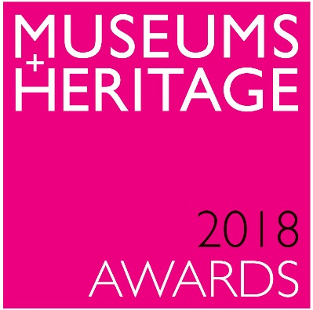

WINNERS ANNOUNCED!

UK’s greatest museums and visitor attractions awarded
at glittering ceremony
Brooklands Museum named Best Permanent Exhibition

London (16 May 2018) – the UK’s museums and heritage visitor attractions are celebrating their remarkable achievements of the last year at the prestigious Museums + Heritage Awards for Excellence 2018.

The winners and runners-up in each of the hard-fought categories were announced by Reverend Richard Coles yesterday (May 16) at the Historic State Rooms of 8 Northumberland Avenue in central London.

Now celebrating its sixteenth year, the annual Awards, judged by a panel of the sector’s most senior players, recognise the innovators and leaders of the diverse world of museums, galleries and cultural and heritage visitor attractions.

Among the night’s winners was Brooklands Museum for its new factory and flight shed which took the ceremony’s big accolade, winning the Best Permanent Exhibition award. This new exhibition has it all – it’s immersive, creative and people-focused. The judges were impressed by its risk-taking and the challenging way it has so brilliantly brought its collection alive.

In a one-off Special Recognition Award, nominated by the Judges, the Wolfson Foundation was rewarded for its continued and critical support of the sector. Paul Ramsbottom, Chief Executive of the Foundation accepted the award saying “One of the joys and one of the peculiarities of funders, is that our achievements and our successes are only achievable through partnership with others. Our success is only possible because of your success and you really are a remarkable sector. Philanthropy is probably more important to the sector now than ever. Our constant message is that philanthropy works alongside government funding and doesn’t work if it replaces government funding. Which is why our recent report Why Collect? calls cleary and unequivocally for more public funding for your sector.”

Amongst the other 2018 winners were:

Innovation Award: Museum of London Archaeological Archive for #ArchiveLottery; Restoration or Conservation Award: The Royal Parks, Brompton Cemetery Conservation Project; Best Educational Initiative: UCL Museums and Collections for Museums on Prescription; Fundraising Initiative of the Year: Haslemere Educational Museum for Museum in a Million; Project on a Limited Budget: Grant Museum of Zoology, The Whale Weekender; Best Marketing Campaign: The Postal Museum and Mail Rail for their launch campaign; Temporary or Touring Exhibition Award: The Salisbury Museum, Terry Pratchett: His World; The International Award: Holland Open Air Museum for the Canon of Dutch History.

Retailing in museums was also recognised with two new awards. The first being for the best shop with a turnover of more than £500k, the winner of which was Tower Bridge for their recently refurbished gift shop. The second of these two awards was for the best shop with a turnover of less than £500k which went to the Royal Albert Memorial Museum & Art Gallery in Exeter.

The final accolades of the ceremony were awarded for volunteering with joint winners being announced for the Individual Volunteer of the Year award: Claire Madge for her work at the Museum of London and to Jessica Arnold who volunteers at the Mid Hants Railway. Also awarded, was the Volunteer Team of the Year which went to the Scottish football Museum’s Football Memories Volunteer Network.

Regarded as the Oscars of the museums and heritage industry, the Awards ceremony is attended by hundreds of sector professionals who join to celebrate the incredible achievements and groundbreaking projects of the past 12 months.
The Awards are judged by a panel of sector experts including: Maggie Appleton MBE, Chief Executive Officer, Royal Air Force Museum; Stephen Duncan, Director of Commercial and Tourism, Historic Environment Scotland; Bernard Donoghue, Director, ALVA; Diane Lees CBE, Director General, Imperial War Museums; Dr Matthew Tanner MBE, Chief Executive of the ss Great Britain Trust and Sam Mullins, Director, London Transport Museum.

ENDS
Note to Editors:
The Museums + Heritage Awards were launched in 2003 by the organisers of The Museums + Heritage Show – the sector’s biggest trade event for museum and heritage/cultural visitor attraction professionals. The Museums + Heritage Show is an annual event taking place at Olympia Exhibition Centre, London on 16+17 May 2018.

For more information about the Awards or the Show and a full list of Winners and Highly Commended attractions, please visit www.museumsandheritage.com or call 01905 724734.

Press enquiries: For further details about the Awards or any of the winners or highly commended attractions, please contact Anna Preedy anna@museumsandheritage.com

awards.museumsandheritage.com

